# Lab Four Project Plan:

You need to develop a project plan that your two teams can use as a way to coordinate your activities. Be sure to post this to MyCourses after you have developed it.

## Deliverables:

Project plans turned in should meet or touch on the following requirements

* Preliminary report of functionality what is the goal of this lab? What services do you plan to deploy and what architecture do you plan to use to do it?
* Expected deliverables of the project
* Links to relevant research if necessary. Reading a few stackoverflow or RFCs before beginning something goes a long way.
* Expected issues or pit falls
* Time line of the steps in the project with people and completion dates assigned to the steps.

These should be helpful to outsiders or other teams. Keep that in mind while writing.

# Project Plan:

|  |  |
| --- | --- |
| Group Number: | 4 |
| Group Members: | Nate Bachelder (Formerly Williams), Steffen Barr, Eli Hopkins, Xavier Rivera |
|  |  |
|  |  |
| Version/Lab Number: | 4 |
| Date: | 12/13/21 |

NSSA 320 Project plan to be completed by each group to help the group develop a plan to complete a lab. Fill in the table below with a short description that answers the question.

## Project Description:

|  |  |
| --- | --- |
| What are your project goals | The goal of this project is to successfully develop a process that will load new versions of the Explore California site to dev servers then transfer them to prod servers after the version is confirmed to be working. |
| What do you aim to accomplish? | We aim to successfully create and then implement this process in the lab environment |
| What additional resources are required? | N/A |
| Success/Definition of successful completion | The project has been completed successfully if our process works stably and as intended while following the given security constraints. |

Below is an example timeline that can serve as the basis of your group Gantt chart for completion of the lab. Be sure to assign people to the individual steps.

## Project Timeline and Order with Milestones

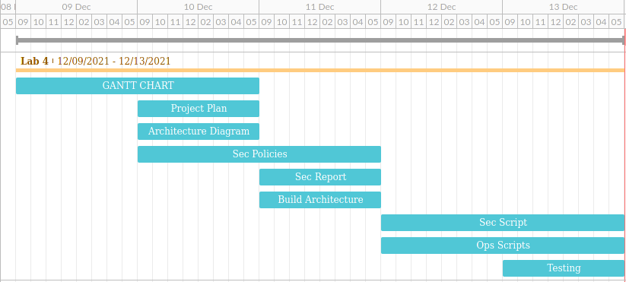

## Visio Diagram of your completed deployment architecture:

